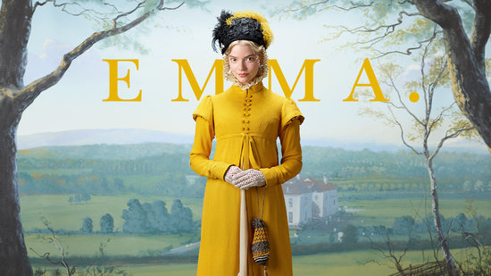

FILM FESTIVAL

|  |  |
| --- | --- |
| **DIRECTOR** | Autumn de Wilde |
| **YEAR/COUNTRY** | 2020 / USA |
| **DURATION** | 124 Min. |
| **LANGUAGE** | English with English subtitles |
| **GENRE** | Romantic Comedy |
| **ACTORS** | Anya Taylor Joy, Mia Goth, Johnny Flynn |

***ABOUT THE MOVIE***

EMMA

MOVIES&LANGUAGES

2024-2025

The film takes its name from the Jane Austen novel and is the tale of Emma Woodhouse, a wealthy and elegant young woman living with her father in regency era England. One of Emma's favourite past times is using her match making skills, which leads to numerous complications especially given the era in which the story is set and the complicated social mores that lay behind society in the regency era period. As the film progresses, we get to witness the way the aristocracy lived their lives and watch as the love story unfolds between all the characters involved in the drama.

***PLOT***

***LANGUAGE***

The film is set during the Regency period and is mostly filmed with characters from the aristocracy. Therefore, the language used and encountered in the film is both highly formal and quite antiquated.

***VOCABULARY***

|  |  |
| --- | --- |
| **How am I to bear it** | **how can I stand it** |
| **A friend such as few possess** | **not many people have such a good friend** |
| **But little short of a mother** | **a cold person, not affectionate** |
| **You would not wish away your grandsons** | **you should be grateful to have grandsons** |
| **That I made the match myself** | **I arranged for them to become involved with each other** |
| **Foretell things** | **predict future events** |
| **You will catch your death!** | **you will get a heavy cold** |
| **Get my bonnet on for trembling!** | **not able to put on my hat because I shake so much** |
| **Why do you turn about?**  **I have a fancy that** | **why are you constantly looking over your shoulder**  **I have a feeling that** |
| **When he came of age** | **when he became an adult** |
| **Speak of him so highly** | **to speak very well about somebody** |

|  |  |
| --- | --- |
| **She was born out of wedlock** | **born to unmarried parents** |
| **I am extremely partial to** | **I am very fond of** |
| **Oh, such bounty** | **such abundance** |
| **It is a beautiful, balmy evening** | **lovely warm evening** |
| **A long face** | **a sad face** |
| **Emma bears everything very well,** | **Emma handles most things very well** |
| **I dare say he might** | **I believe that he will** |
| **Support your claim to that station** | **provide evidence to support this statement** |
| **We must have you to Hartfield** | **we must invite you to Hatfield** |
| **In normal course she writes Tuesday** | **normally she writes on a Tuesday** |
| **The sudden whirling round of** | **spinning out of control** |
| **Dashed to the sea at once** | **immediately thrown into the sea** |
| **I had no notion that** | **I had no idea that** |
| **I am so seldom indisposed** | **it is unusual to find myself in this position** |
| **I rather wonder** | **I really wonder** |
| **Her ignorance is hourly flattery** | **her ignorance is so apparent that it constantly shows** |
| **Requiring industry and patience** | **requiring intelligence and patience** |
| **Did you ever have your likeness taken, Harriet** | **have you ever had your portrait painted** |

|  |  |
| --- | --- |
| **Harriet only wanted drawing out** | **once Harriet understood, she was then more than capable of….** |
| **I never met with a disposition** | **I have never come across somebody with such an attitude** |
| **I’m really most obliged to you** | **I am so grateful to you** |
| **May I be so bold as to seek your advice?** | **do you mind very much if I ask you** |
| **Martin has offered me his hand** | **Martin has asked me to marry him** |
| **Custard** | **an English dessert** |
| **It would have grieved me to lose you** | **it would have been painful for me to lose you** |
| **It would have been a severe pang** | **a lot of emotional pain** |
| **Nothing has been grudged** | **nothing has been withheld** |
| **She is known only as a parlour boarder at a common school** | **privileged category of pupil at a boarding school** |
| **Love of matchmaking** | **the joy of introducing prospective lovers** |
| **You certainly spared no expense** | **money was no object** |
| **South End** | **Victorian seaside town** |
| **You are so disheveled** | **you are a mess** |
| **Shall I ask to bank the fire?** | **to add more fuel to the fire** |
| **Were she a person of consequence** | **if she was an important person** |
| **Do not vex my father** | **do not make my father angry** |
| **Look to your vinaigrette** | **small container containing aromatic substances** |

|  |  |
| --- | --- |
| **Harriet only wanted drawing out** | **once Harriet understood, she was then more than capable of….** |
| **I never met with a disposition** | **I have never come across somebody with such an attitude** |
| **I’m really most obliged to you** | **I am so grateful to you** |
| **May I be so bold as to seek your advice?** | **do you mind very much if I ask you** |
| **Martin has offered me his hand** | **Martin has asked me to marry him** |
| **Custard** | **an English dessert** |